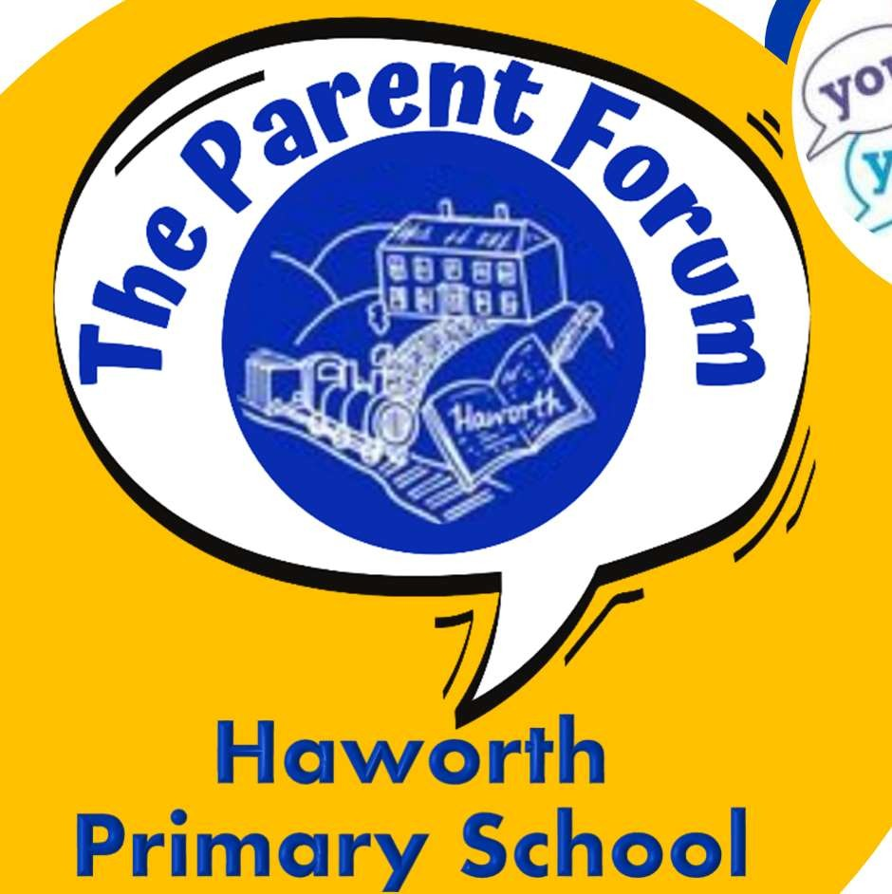
Haworth Primary School Parent Forum Newsletter
April 2022

Welcome to The Parent Forum

Our group aims to give the parents & carers of children at Haworth Primary School a voice on school matters.
As parents attending the previously named ‘Solve-It’ groups, we have already seen how effective collaboration between parents & school can enhance school policy. We hope to expand this group to include a larger cross-section of parents so that it is truly representative of our parent
body.

Notes from Thursday 5th May 2022

We were delighted to be joined by Andy Longden, who is a member of the School Academy Committee with responsibility for community engagement.

- Cycling to school – the school has been asked if we have facilities o lock up bikes and scooters, should children wish to ride to school. The group discussed the idea and decided to send a survey to parents/carers to gauge the amount of interest for cycling/scooting to school and then plans can be put into place. Watch this space for more information.

- Fund raising for Manorlands – previously the children took part in a tough mudder style race, this year the children have asked if they could have a Colour dash race. The date has been provisionally booked for the last day of the Summer term. Andy Longden offered his support for the event. Mrs. Gurney is looking at the logistics and costs of the paints and another survey will be sent to parents. The Friends fundraising committee have offered to book an ice-cream van on this day as a treat for the whole school.

- The Bungalow /Hub - flooring was fitted on the week of the meeting and the Baby and Toddle group was cancelled for 2 weeks to allow time to move into the bungalow. The groups will resume again week commencing 23rd May 2022. We are looking for suggestions for other activities /sessions to be available in the Hub. Ideas so far Second-hand uniform shop, Parent Coffee Morning and a Book Swop.

- Engaging more parents/carers to attend our meeting, that is over to you… how can we attract more parents to our meetings? Do you have any bright ideas? Please let us know either catch Mrs Morris in the playground or email the office. We would love more families to be involved

Next meeting:
Monday 13th June 2.45pm

Next meeting Dates:
Monday 13th June 2022 @ 2.45pm

