Haworth Primary School
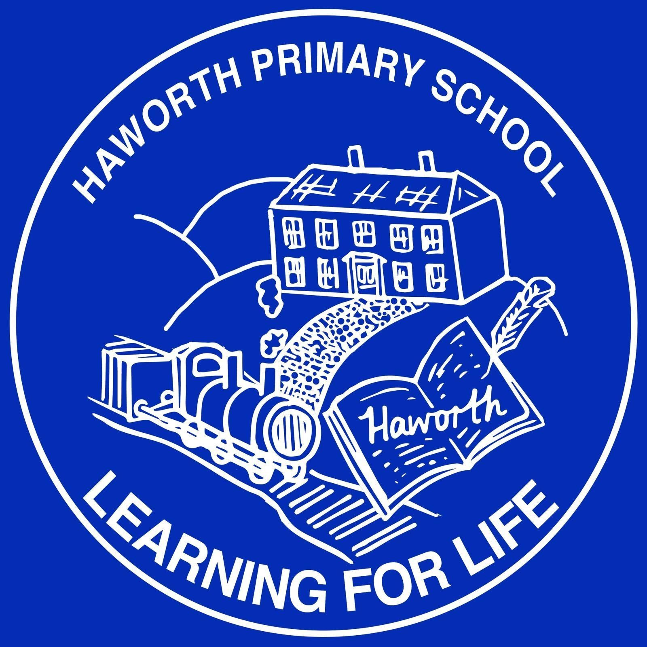
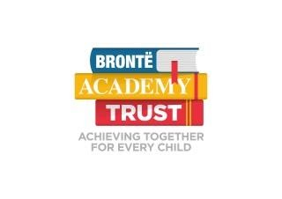
N E W S L E T T E R
Issue 20 May 2022
Hello,

Well another lovely half term here at Haworth Primary school, the arrival of some sun definitely helps!
As usual our Facebook page has been busy detailing the exciting opportunities and learning taking place, we hope you continue to enjoy these. The children are enjoying receiving the Kindness awards and welcoming the opportunity to celebrate these small gestures that contribute to maintaining our warm and thoughtful environment. All staff are sending certificates to me ready for our Monday whole school assembly and we have had to order more stock!

This term we have had Year 6 SATs and Year 2 'fun quizzes' next half term the Phonics and multiplication check. The children respond well to these and it is testament to the great work that staff do that keeps these necessary assessments low key and almost enjoyable.

As usual the children will have their last day in their present class (this year it is the 8th July) and Monday sees them start their new classes. More information to follow after half term regarding staffing, routines etc. There will be an opportunity to come and meet with the new teacher (where possible) but the children will certainly be receiving a welcome email and plenty of contact to support this transition. We find that this process ensures the children have an easy, calm summer as the routines and relationships are already established.

For our Year 6 leavers there will be opportunities to meet not only with their friends across the Trust but their new school staff in preparation for their next exciting steps on their educational journey.

We hope you have a lovely Spring Bank break as always, thank you for your ongoing support.
Regards,
Mrs Howe

Foundation Stage – Robin (Nursery), Owl & Swan (Reception)
Nursery and Reception children enjoyed an exciting start to this half term as Zoo Lab visited with lots of interesting creatures. Children learnt lots of new animal facts and got to handle giant snails, stick insects, hissing cockroaches and giant millipedes! We found out where these creatures originate from and began to find out more about other places in the world.
Children in both classes also learnt about Eid, decorating the rooms and enjoying a celebration together.
We are currently learning about our Queen and getting ready for the Jubilee celebration on the last day before half term.

Key Stage 1 Sparrow, Blackbird & Puffin (Year 1 & 2)
Year 1/2 have had a very busy half term; our topic was all about castles and we looked at the layout of castles and the different job roles within a castle. Science has been so exciting, creating our very own boats and testing how waterproof they were! For our fab finish we are using our Design Technology skills to create a Jack and the Beanstalk book with moving parts.
A big well done to our amazing Year 2’s on the completion of their SAT’s, you were all brilliant!

Lower Key Stage 2 Skylark, Woodpecker & Kingfisher (Year 3 & 4)
In our topic work we have been exploring OS Maps and symbols (specifically looking at Haworth), practising using a compass and comparing maps from past and present. In art, we have been experimenting with different grades of pencil and charcoal to produce different effects in sketching. In the last week of half-term, we hope to sketch our own landscape of Haworth and use watercolours to bring it to life.
We were so lucky to have a poetry workshop with Matt Goodfellow it was amazing. The children had a fabulous time for our fab finish at the Bronte Parsonage to conclude our

Upper Key Stage 2 Heron, Kestrel & Chaffinch (Year 5 & 6)
The amazing Year 6 children handled SAT’s amazingly, we are very proud of each and everyone of you!
It has been a short but busy half term out topic has been ‘Space and Planets’ the children enjoyed learning about the about the moon rotation around the Earth, and the Earth rotation around the Sun. The children then created models to show our learning and to demonstrate the orbit. Our big art/design technology project has been to design and sew our own aliens…They are out of this world!

The Nest
The Nest have had a fantastic half term. Our topic has been all about Space, which our children have thoroughly enjoyed. We have enjoyed learning the order of the planets by listening to a new song, we have made our very own rockets, dressed up like an astronaut and explored our space sensory tray. One of our stories of the week was 'Whatever next' by Jill Murphy and we helped baby bear fly to the moon in our construction area. We have worked really hard on our number formation and sequencing in our Maths and have focussed on our tricky words in our phonics. We are really looking forward to getting back into our sensory garden next half term as the weather improves.

Meet our Governors – This half term Mr Longden our Community Governor has this article
My name is Andy Longden, I am a member of the School Academy Committee with responsibility for community engagement.
A few words about me. I have a big attachment to the school as both my grandsons attended and are now just sitting their GCSE's. How time flies! The school was so supportive to us as a family that I want to give something back.
I am currently employed as a Volunteer Coordinator at Manorlands Hospice. I am married to Joanna and in our spare time we enjoy walking in the lovely countryside.
Enough about me, I would like to hear from you.
I would like to know from you what works well for you and your children at the school and what could be improved or doesn't work quite as well. I would also appreciate any ideas you may have to improve our pupils' school experience.
I can be contacted via andy.longden@bronteacademytrust.org.uk alternatively leave me your contact number and I will call you.

Sports and Club News
KS1 children have been developing their bat and ball skills in tennis and hockey skills in PE this half term. Some children have continued to enjoy dodgeball during their indoor PE. Year 3/4 have also been improving their tennis skills outdoors and practising badminton indoors. Year 5/6 have enjoyed the fun and fast game of Unihoc indoors and the much-loved summer sport of rounders outdoors.
KS2 Running Club - The children have continued to work hard to achieve their miles around the All Weather Pitch to improve their stamina; they will receive a certificate for every 10 miles. They have also been developing their sprints and timing their laps.
Yr3/4 Football - The children have worked on a variety of skills from 'L turns' to 'first time passing' and we appear to have some future international footballers in our school. Thank you to the three coaches from year 5 and 6 who helped Mr Campbell every week.
Maths Club - The children have been practising their methods of addition, subtraction, multiplication and division, using board games. There have been strategic games and team games. Their personal favourite was Monopoly!
Outdoor Explorers - The children have explored the outdoor environment at school and have enjoyed building dens, obstacle courses and making magical lands in the sand area. They have also been on a walk in the woods, played hide and seek, completed challenges and enjoyed hot chocolate and biscuits.
Computer Club - Mr Oakes led a computing club, covering a range of computing skills, including programming.
Debating Club - This half term the KS2 children had the chance to join a debating club with Miss Brown. Children enjoyed learning more about how debates work, the purpose of debating and how to navigate a debate in a polite, thoughtful manner. Several topics were debated including; 'Should dogs be allowed in the classroom?' The children's skills improved over the weeks and Miss Brown believes these skills will be useful throughout KS2 and beyond!
Yoga - A letter will be emailed out soon for the Summer 2 club with Lindsey Vickers.
SportsCool - will be back in Summer 2 with a Tri golf club running on a Tuesday for KS1 and KS2, this letter will also be emailed out this week.
Latitude Sports Coaching - The Lunchtime clubs for R/KS1 and KS2 have been a great success, the children have said how much they have enjoyed them. Next half term they will be offering-football for R/KS1 on a Monday lunchtime and dodgeball will continue for KS2 on a Tuesday as it was so popular!
A Wake up Shake up club is due to begin on a Tuesday morning after the Spring Bank holiday with the Latitude Sports Coaching team. It will be from 8am-8.50 £3 a week offering fun sporting activities to get your child fit and ready for learning and with plenty of fun mixed in!
PE kits should be in School, during term time.

Dates for your Diary
Mon 6th June 2022 | School re- opens
Monday 6th June | All week | Year 6 Bike Proficiency Level 1 & 2 | During School Day
Wednesday 8th June | 6.15pm - 7.15pm | Nursery Welcome Meeting
Monday 13th June | 2.45pm | Parent Forum Meeting | Agenda to follow
Tuesday 14th June | 2.15pm – 3.15pm | Nursery Stay and Play
Tuesday 14th June | 6.15pm – 7.15pm | Reception Class welcome Meeting
Wednesday 15th June | 8.30am - 4.30pm | Y5/6 Countryside Day visit at Harrogate
Thursday 23rd June | 2.30pm | Puffin Class Share a Story Session | More details to follow
Tuesday 28th June |  | Nursery Parents/Carers and Children trip to Eureka | During School day
Tuesday 5th July |  | KS1 Sports Day | More details to follow
Wednesday 6th July |  | Year 3/4 Sports Day | More Details to follow
Thursday 7th July |  | Year 5/6 Sports Day | More details to follow
Week commencing 11th July |  | Transition to new classes
Tuesday 19th July | During the school afternoon | Y6 visit to Stay Safe | More details to follow
Wednesday 20th July | am & pm | Nursery Graduation | More details to follow
Thursday 21st July |  | Colour Dash- fundraising event for Manorlands | More details to follow
Thursday 21st July | School closes 3.20pm

HOSC News
Hi all,
We can’t believe now fast this year is going! Summer is definitely on its way and - when the weather allows - we are spending the majority of our sessions outside. It’s so lovely to see the children playing in the sunshine together, whizzing around the playground on the scooters or just sitting relaxing after a busy day in class. Our footballers are still honing their skills in the bottom playground and it’s becoming clear that we may have some future superstars in our midst!
We remain proud of our Stars of the Week, who are always excellent role models and so helpful to staff and children alike. As always, it is a really difficult choice for our staff choosing the week’s superstars with every single child impressing us in some way.
Just a quick reminder to pack a sunhat and suncream for any the hotter days – but we will obviously keep the children in the shade if required.
Finally, we hope you enjoy the extended Spring Bank holiday together with the Jubilee celebrations.
Take care.
The HOSC Team

